Family Participation Hours Log
10 Hours Needed For Baseball
6 Hours Needed for Softball & Pony

Player Name (s): ________________________

Division & Team: _______________________

Family Name (If Different) _______________

Reimbursement Check payable to:

_______________________________________

Duty & Hours Worked Date Board Approval

FPH Opportunities

- Board Member 10 Hours
- Team Manager 10 Hours
- Team Coach 6 Hours
- Team Mom 10 Hours
- Team Basket 2 Hours
- Concession Stand: Per Hour
- Field Maintenance: Per Hour

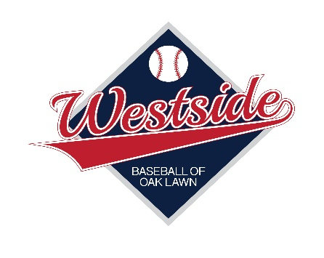

WBOL Baseball & Softball

2023

Family Participation Hours
Personal Log Sheet

Field Maintenance Hours

WBOL will have plenty of opportunities for our families to earn points assisting with Field Maintenance. Through Sign-Up Genius there will be dates and times available for sign-up. The link will be e-mailed to our families. Be sure to have this sheet initialed by the person in charge of the clean up before you leave or you will not get credit.

Concession Stand

Another great opportunity to earn part or all of your points is to volunteer at Westside’s concession stand. Each volunteer will receive 10 points per hour worked. More than 1 volunteer representing a single family may work the same shift at one time to earn points.
The concession stand is always in need of volunteers in order to run successfully as Westside is a volunteer-based organization. You may earn your points outside of your teams’ regularly scheduled dates also.
Once you have finished your shift make sure you see a concession stand supervisors or a nearby Westside Board Member to sign-off on your hours volunteered. Please make sure this signature is obtained BEFORE you leave as we cannot sign-off on previous volunteer hours once you leave the Westside premises.

